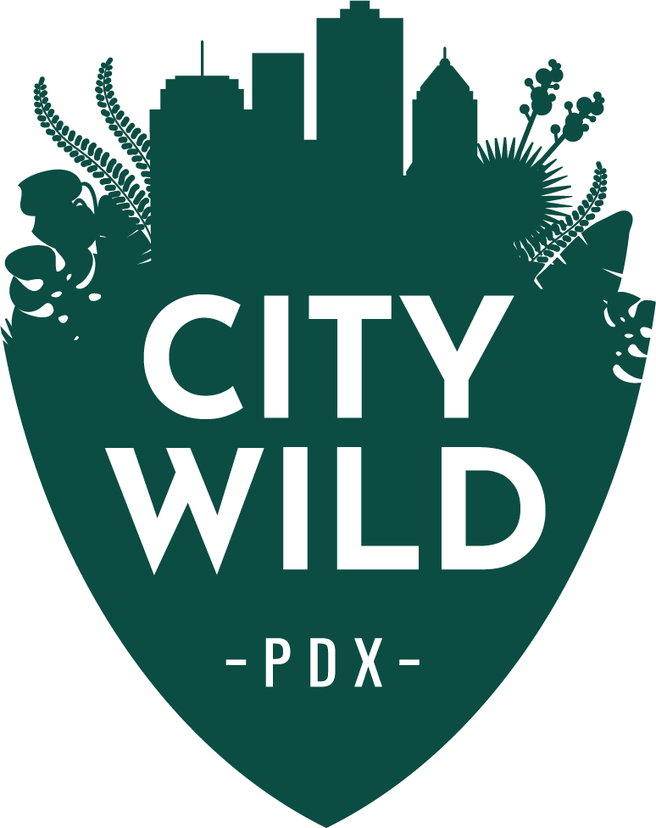
From curiosity comes learning,
from learning comes respect,
from respect comes stewardship.

New Board Member Interest Form – 2018
Due April 15th, 2018

Name:
Phone & Email:
Address:
Occupation/Employer:

1. Tell us how you learned about CityWildPDX.

2. Why are you interested in joining our Board of Directors?

3. If you currently serve or have served on any nonprofit board(s) in the past, please provide us with the name of the organization, years served, and what role(s) you served on the board(s).

4. What unique expertise or experience can you bring to CityWildPDX?

5. Are you able to commit to attending 6 board meetings a year, volunteering approximately 5 hours per month?

6. From the list below, please identify your specific area(s) of expertise which align with our organizational needs, describe your expertise and/or interest in each topic that you have selected, and how that expertise will benefit CityWildPDX:
- environmental education
- marketing/communications
- diversity, equity and inclusion
- non-profit management
- fundraising and development
- community outreach (especially in low income communities and communities of color in the Portland region)
7. Please attach a resume, and include at least two personal or professional references including their contact information.

8. What’s your favorite way of connecting with nature in the city and why is it important to you?

9. Is there anything else you’d like us to know about you?

*Please submit your application by emailing it to bcrowmiller@gmail.com

